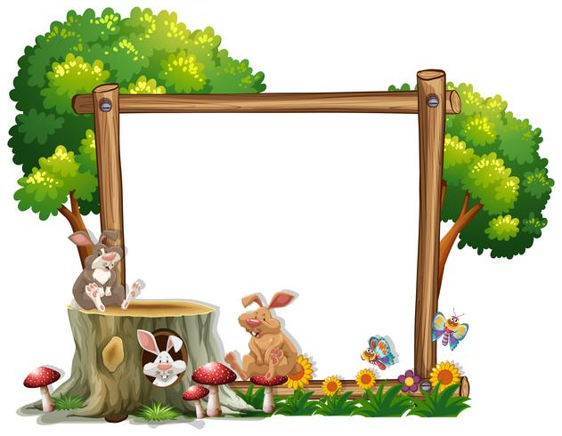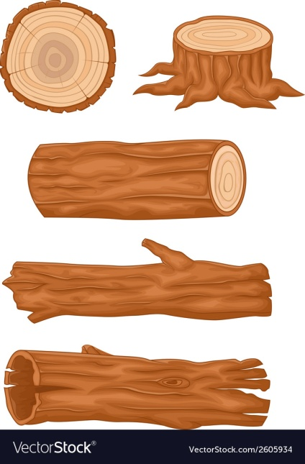

Breakfast

A selection of cereals

Morning Snack

Toast

Dinner

Mixed vegetable mozzarella crumble

Dessert

Refreshing lemon cheesecake

Afternoon Snack

Fresh fruit platter

Tea

Pizza’s

Friday

Thursday

Wednesday day

Tuesday day

Monday

Breakfast

A selection of cereals

Morning Snack

Toast

Dinner

Homemade Fishermans pie

Dessert

Cake and custard

Afternoon Snack

Fresh fruit platter

Tea

Celery soup & roll

Breakfast

A selection of cereals

Morning Snack

Toast

Dinner

Cheese and onion flan served with fluffy mash and beans

Dessert

Milky pudding

Afternoon Snack

Fresh fruit platter

Tea

Jacket potatoes

Served with tuna and sweetcorn

**Week 2**

Breakfast

A selection of cereals

Morning Snack

Toast

Dinner

Cream cheese dip with vegetable sticks followed by chilli and rice

Dessert

Homemade shortbread

Afternoon Snack

Fresh fruit platter

Tea

Beans on toast

Breakfast

A selection of cereals

Morning Snack

Toast

Dinner

Melting meatball bake

Dessert

Jelly

Afternoon Snack

Fresh fruit platter

Tea

Hotdogs with onions

Monday