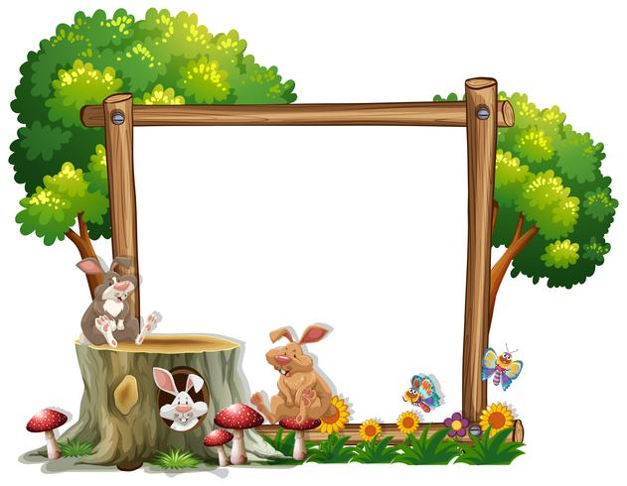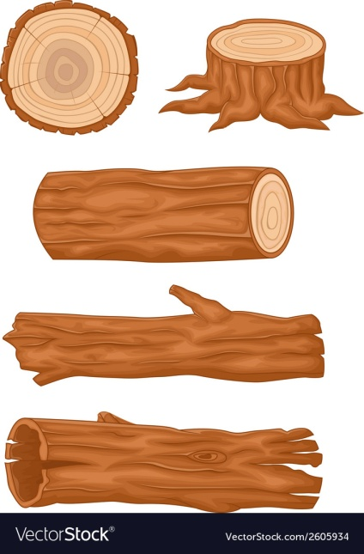

Breakfast

A selection of cereals

Morning Snack

Toast

Dinner

Chinese chicken curry served with brown rice and prawn crackers

Dessert

Soft cheese & crackers

Afternoon Snack

Fresh fruit platter

Tea

Sausage &

beans

Friday

Thursday

Wednesday day

Tuesday day

Monday

Breakfast

A selection of cereals

Morning Snack

Toast

Dinner

Healthy fish and chips

Dessert

Homemade fairy cakes

Afternoon Snack

Fresh fruit platter

Tea

Vegetable soup

**Week 4**

Breakfast

A selection of cereals

Morning Snack

Toast

Dinner

Quiche, baby potatoes & beans

Dessert

Apple crumble and custard

Afternoon Snack

Fresh fruit platter

Tea

Ham sandwiches with vegetable sticks

Breakfast

A selection of cereals

Morning Snack

Toast

Dinner

Tuna Salad

Dessert

Ice cream

Afternoon Snack

Fresh fruit platter

Tea

Ravioli on toast

Breakfast

A selection of cereals

Morning Snack

Toast

Dinner

Cheesy ham and vegetable bake

Dessert

Fruit cake

Afternoon Snack

Fresh fruit platter

Tea

Homemade potato and leek soup with a bread roll

Monday