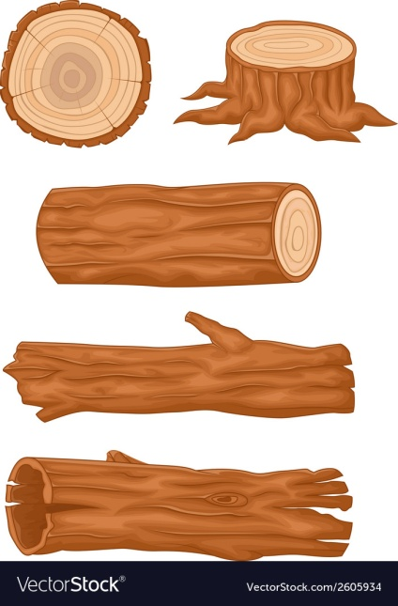

Friday

Thursday

Wednesday day

Tuesday day

Monday

Breakfast

A selection of cereals

Morning Snack

Toast

Dinner

Homemade Fishermans pie

Dessert

Ice cream

Afternoon Snack

Fresh fruit platter

Tea

Vegetable soup & roll

Breakfast

A selection of cereals

Morning Snack

Toast

Dinner

Chicken pasta salad

Dessert

Soft sponge and custard

Afternoon Snack

Fresh fruit platter

Tea

Meatballs and

rice served

with a divine

tomato sauce

**Week 1**

Breakfast

A selection of cereals

Morning Snack

Toast

Dinner

Fluffy homemade cottage pie served with vegetables

Dessert

Homemade shortbread

Afternoon Snack

Fresh fruit platter

Tea

Jacket potato with cheesy beans

Breakfast

A selection of cereals

Morning Snack

Toast

Dinner

A mild aromatic chicken curry served with rice

Dessert

Yogurts

Afternoon Snack

Fresh fruit platter

Tea

Ham and tomato sandwiches

Breakfast

A selection of cereals

Morning Snack

Toast

Dinner

Cheesy pasta bake with a selection of vegetables

Dessert

Fresh fruit salad

Afternoon Snack

Fruit flapjacks

Tea

Lentil soup with a crusty roll

Monday