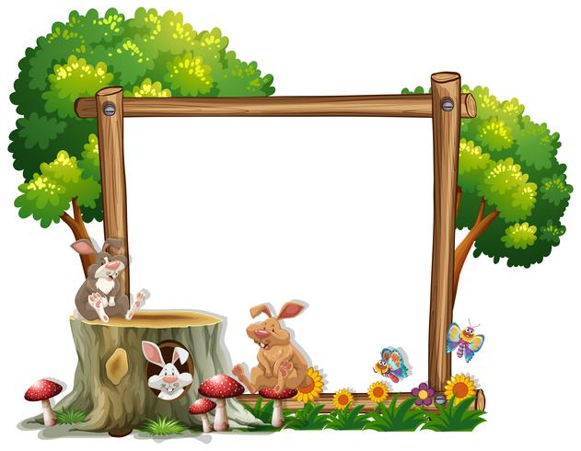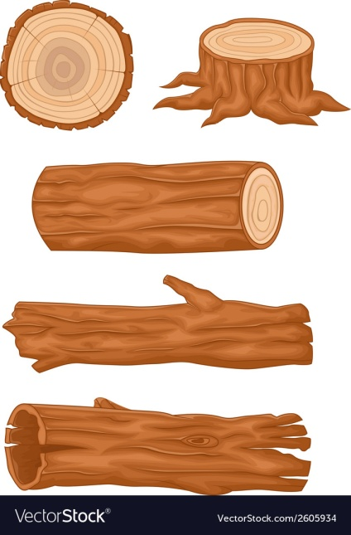

Breakfast

A selection of cereals

Morning Snack

Toast

Dinner

Vegetable lasagne

Dessert

Fruit salad

Afternoon Snack

Fresh fruit platter

Tea

Ham wraps & vegetable sticks

Friday

Thursday

Wednesday day

Tuesday day

Monday

Breakfast

A selection of cereals

Morning Snack

Toast

Dinner

Healthy fish and chips

Dessert

Homemade biscuits

Afternoon Snack

Fresh fruit platter

Tea

Soup & roll

**Week 3**

Breakfast

A selection of cereals

Morning Snack

Toast

Dinner

Tomato pasta

Dessert

Jelly

Afternoon Snack

Fresh fruit platter

Tea

Egg mayonnaise sandwiches

Breakfast

A selection of cereals

Morning Snack

Toast

Dinner

Chicken salad with new potatoes

Dessert

Ice cream cones

Afternoon Snack

Fresh fruit platter

Tea

Vegetable pasta bake

Breakfast

A selection of cereals

Morning Snack

Toast

Dinner

Creamy tomato soup served with garlic bread

Dessert

Pineapple upside down cake

Afternoon Snack

Fresh fruit platter

Tea

Beans on toast

Monday